**Vadodar**

**Dat**



Mobile Application Development

**(BE031000081)**

LABORATORY MANUAL

**B.E. Semester-III**

**Prepared By:- CE/IT Department**

**Vadodara Institute of Engineering (080) Kotambi, Vadodara – 391510**

**Academic Year : 2025-2026**

# Index

|  |  |
| --- | --- |
| **Sr No** | **Practicals** |
| **1** | Write android program to display "Welcome to android". |
| **2** | Write android program to demonstrate usage of string. |
| **3** | Write android program to demonstrate activity life cycle. |
| **4** | Write android program to change the background of activity. |
| **5** | Write android program to perform all operation in calculator. |
| **6** | Write android program to create multiple activities within an application. |
| **7** | Write android program to demonstrate action button by implementing ONCLICKLISTENER. |
| **8** | Write android program to demonstrate sound button application. |
| **9** | Write an Android application to convert into different currencies for example, Rupees to dollar. |
| **10** | Write an android application to count library overdue. |
| **11** | Write an android application to convert a ball from size of radius 2(colour red) to radius 4(colour blue) to radius 6 (colour green). The ball must rotate in circle for 1 minute before changing size and colour. |
| **12** | Write an application to mark the daily route of travel in map. |
| **13** | Write an application to record video and audio on topic "Intent" and play the audio and video |
| **14** | Write android program to set the wallpaper of your device using bitmap class. |

**Software Requirements**

|  |  |  |
| --- | --- | --- |
| **Sr No** | **Software Requirement** | **Hardware Requirement** |
| **1** | Android Studio | 64-bit OS |
|  |  | RAM-16 GB |
|  |  | Processor (Intel i5/i7, AMD Ryzen, etc.) |
|  |  | Hard Disk- 512 GB |

**Date:**

# Practical 1

**AIM: Write Android program to display "Welcome to android".**

<!-- res/layout/activity_main.xml -->

<?xml version="1.0" encoding="utf-8"?>

<LinearLayout xmlns:android="http://schemas.android.com/apk/res/android"

android:layout_width="match_parent"

android:layout_height="match_parent"

android:gravity="center"

android:orientation="vertical">

<TextView

android:id="@+id/textView"

android:layout_width="wrap_content"

android:layout_height="wrap_content"

android:text="Welcome to android"

android:textSize="24sp"

android:textStyle="bold"/>

</LinearLayout>

**Output:**

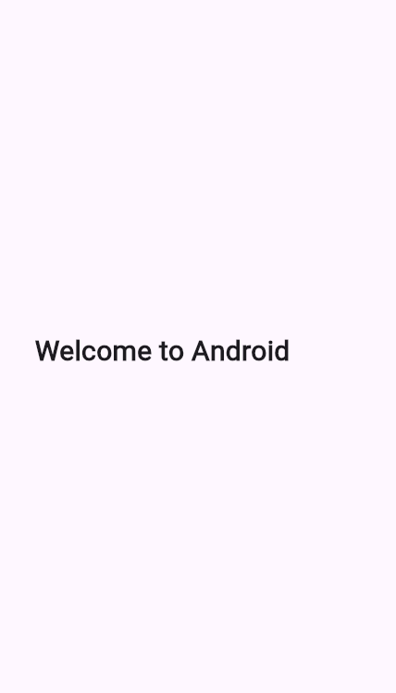

**Date:**

# Practical 2

**AIM:** **Write android program to demonstrate usage of string.**

## Program:

## <?xml version="1.0" encoding="utf-8"?>

## <LinearLayout xmlns:android="http://schemas.android.com/apk/res/android"

## android:layout_width="match_parent"

## android:layout_height="match_parent"

## android:orientation="vertical"

## android:gravity="center"

## android:padding="20dp"

## android:background="#FFFFFF">

## <TextView

## android:id="@+id/textViewResult"

## android:layout_width="wrap_content"

## android:layout_height="wrap_content"

## android:text="String Example"

## android:textSize="22sp"

## android:textColor="#000000" />

## </LinearLayout>

**Main Activity.java**

package com.example.stringdemo;

import androidx.appcompat.app.AppCompatActivity;

import android.os.Bundle;

import android.widget.TextView;

public class MainActivity extends AppCompatActivity {

@Override

protected void onCreate(Bundle savedInstanceState) {

super.onCreate(savedInstanceState);

setContentView(R.layout.activity_main);

TextView textView = findViewById(R.id.textViewResult);

// String usage demonstration

String firstName = "Android";

String lastName = "Programming";

// Concatenation

String fullName = firstName + " " + lastName;

// Display result

textView.setText("Concatenated String: " + fullName);

}

}

**Output:**

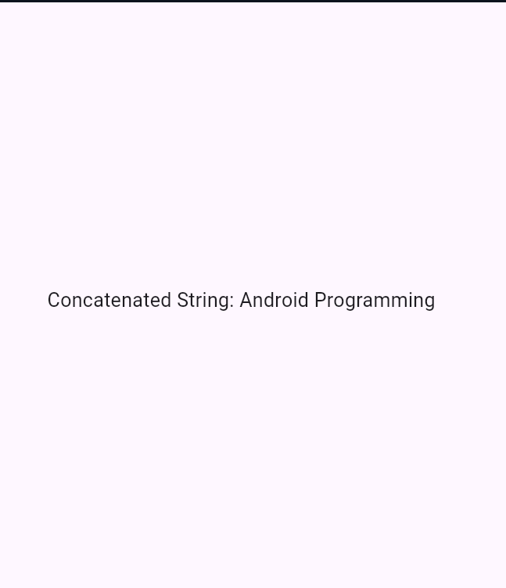

**Date:**

# Practical 3

**AIM: Write android program to demonstrate activity life cycle.**

## Program:

## XML Layout (activity_main.xml)

<?xml version="1.0" encoding="utf-8"?>

<LinearLayout xmlns:android="http://schemas.android.com/apk/res/android"

android:layout_width="match_parent"

android:layout_height="match_parent"

android:orientation="vertical"

android:gravity="center"

android:background="#FFFFFF"

android:padding="20dp">

<TextView

android:id="@+id/textViewLifeCycle"

android:layout_width="wrap_content"

android:layout_height="wrap_content"

android:text="Activity Life Cycle Demo"

android:textSize="20sp"

android:textColor="#000000"/>

</LinearLayout>

**Java Code (MainActivity.java)**

package com.example.lifecycleapp;

import androidx.appcompat.app.AppCompatActivity;

import android.os.Bundle;

import android.util.Log;

import android.widget.TextView;

public class MainActivity extends AppCompatActivity {

private static final String TAG = "ActivityLifeCycle";

TextView textView;

@Override

protected void onCreate(Bundle savedInstanceState) {

super.onCreate(savedInstanceState);

setContentView(R.layout.activity_main);

textView = findViewById(R.id.textViewLifeCycle);

textView.setText("onCreate() called");

Log.d(TAG, "onCreate() called");

}

@Override

protected void onStart() {

super.onStart();

Log.d(TAG, "onStart() called");

}

@Override

protected void onResume() {

super.onResume();

Log.d(TAG, "onResume() called");

}

@Override

protected void onPause() {

super.onPause();

Log.d(TAG, "onPause() called");

}

@Override

protected void onStop() {

super.onStop();

Log.d(TAG, "onStop() called");

}

@Override

protected void onRestart() {

super.onRestart();

Log.d(TAG, "onRestart() called");

}

@Override

protected void onDestroy() {

super.onDestroy();

Log.d(TAG, "onDestroy() called");

}

}

**Output:**

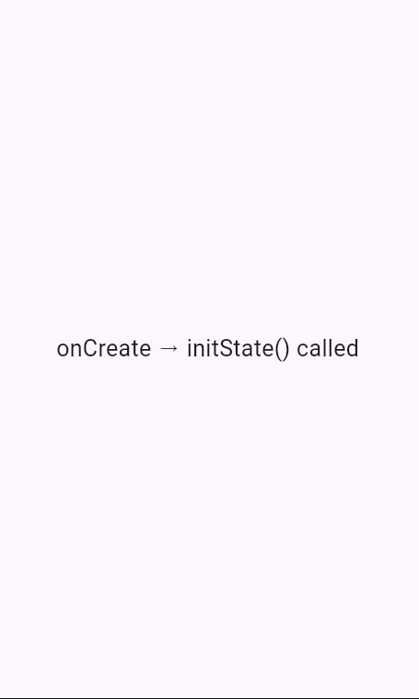

**Date:**

# Practical 4

**AIM: Write android program to change the background of activity.**

## Program:

XML Layout (activity_main.xml)

## <?xml version="1.0" encoding="utf-8"?>

## <LinearLayout xmlns:android="http://schemas.android.com/apk/res/android"

## android:layout_width="match_parent"

## android:layout_height="match_parent"

## android:orientation="vertical"

## android:gravity="center"

## android:padding="20dp"

## android:id="@+id/mainLayout">

## <Button

## android:id="@+id/btnChangeColor"

## android:layout_width="wrap_content"

## android:layout_height="wrap_content"

## android:text="Change Background" />

## </LinearLayout>

## Java Code (MainActivity.java)

## package com.example.backgrounddemo;

## import androidx.appcompat.app.AppCompatActivity;

## import android.os.Bundle;

## import android.graphics.Color;

## import android.view.View;

## import android.widget.Button;

## import android.widget.LinearLayout;

## public class MainActivity extends AppCompatActivity {

## LinearLayout mainLayout;

## Button btnChange;

## @Override

## protected void onCreate(Bundle savedInstanceState) {

## super.onCreate(savedInstanceState);

## setContentView(R.layout.activity_main);

## mainLayout = findViewById(R.id.mainLayout);

## btnChange = findViewById(R.id.btnChangeColor);

## btnChange.setOnClickListener(new View.OnClickListener() {

## @Override

## public void onClick(View v) {

## // Change background color on button click

## mainLayout.setBackgroundColor(Color.CYAN);

## }

## });

## }

## }

## Output :

## 

**Date:**

# Practical 5

**AIM: Write android program to perform all operation in calculator.**

## Program:

## XML Layout (activity_main.xml)

<?xml version="1.0" encoding="utf-8"?>

<LinearLayout xmlns:android="http://schemas.android.com/apk/res/android"

android:layout_width="match_parent"

android:layout_height="match_parent"

android:orientation="vertical"

android:padding="20dp"

android:gravity="center"

android:id="@+id/mainLayout">

<EditText

android:id="@+id/etNum1"

android:layout_width="match_parent"

android:layout_height="wrap_content"

android:hint="Enter First Number"

android:inputType="numberDecimal"

android:layout_marginBottom="10dp"/>

<EditText

android:id="@+id/etNum2"

android:layout_width="match_parent"

android:layout_height="wrap_content"

android:hint="Enter Second Number"

android:inputType="numberDecimal"

android:layout_marginBottom="20dp"/>

<LinearLayout

android:layout_width="match_parent"

android:layout_height="wrap_content"

android:orientation="horizontal"

android:gravity="center"

android:layout_marginBottom="20dp">

<Button

android:id="@+id/btnAdd"

android:layout_width="wrap_content"

android:layout_height="wrap_content"

android:text="+" />

<Button

android:id="@+id/btnSub"

android:layout_width="wrap_content"

android:layout_height="wrap_content"

android:text="-"

android:layout_marginLeft="10dp"/>

<Button

android:id="@+id/btnMul"

android:layout_width="wrap_content"

android:layout_height="wrap_content"

android:text="×"

android:layout_marginLeft="10dp"/>

<Button

android:id="@+id/btnDiv"

android:layout_width="wrap_content"

android:layout_height="wrap_content"

android:text="÷"

android:layout_marginLeft="10dp"/>

</LinearLayout>

<TextView

android:id="@+id/tvResult"

android:layout_width="wrap_content"

android:layout_height="wrap_content"

android:text="Result will be shown here"

android:textSize="20sp"

android:textColor="#000000"/>

</LinearLayout>

**Java Code (MainActivity.java)**

package com.example.calculatordemo;

import androidx.appcompat.app.AppCompatActivity;

import android.os.Bundle;

import android.view.View;

import android.widget.Button;

import android.widget.EditText;

import android.widget.TextView;

import android.widget.Toast;

public class MainActivity extends AppCompatActivity {

EditText etNum1, etNum2;

Button btnAdd, btnSub, btnMul, btnDiv;

TextView tvResult;

@Override

protected void onCreate(Bundle savedInstanceState) {

super.onCreate(savedInstanceState);

setContentView(R.layout.activity_main);

etNum1 = findViewById(R.id.etNum1);

etNum2 = findViewById(R.id.etNum2);

btnAdd = findViewById(R.id.btnAdd);

btnSub = findViewById(R.id.btnSub);

btnMul = findViewById(R.id.btnMul);

btnDiv = findViewById(R.id.btnDiv);

tvResult = findViewById(R.id.tvResult);

btnAdd.setOnClickListener(new View.OnClickListener() {

@Override

public void onClick(View v) {

calculate('+');

}

});

btnSub.setOnClickListener(new View.OnClickListener() {

@Override

public void onClick(View v) {

calculate('-');

}

});

btnMul.setOnClickListener(new View.OnClickListener() {

@Override

public void onClick(View v) {

calculate('*');

}

});

btnDiv.setOnClickListener(new View.OnClickListener() {

@Override

public void onClick(View v) {

calculate('/');

}

});

}

private void calculate(char operator) {

String num1Str = etNum1.getText().toString();

String num2Str = etNum2.getText().toString();

if (num1Str.isEmpty() || num2Str.isEmpty()) {

Toast.makeText(this, "Please enter both numbers", Toast.LENGTH_SHORT).show();

return;

}

double num1 = Double.parseDouble(num1Str);

double num2 = Double.parseDouble(num2Str);

double result = 0;

switch (operator) {

case '+':

result = num1 + num2;

break;

case '-':

result = num1 - num2;

break;

case '*':

result = num1 * num2;

break;

case '/':

if (num2 != 0) {

result = num1 / num2;

} else {

Toast.makeText(this, "Cannot divide by zero", Toast.LENGTH_SHORT).show();

return;

}

break;

}

tvResult.setText("Result: " + result);

}

}

## Output :

## 

**Date:**

# Practical 6

**AIM: Write android program to create multiple activities within an application.**

## Program:

## XML Layout for MainActivity (activity_main.xml)

## <?xml version="1.0" encoding="utf-8"?>

## <LinearLayout xmlns:android="http://schemas.android.com/apk/res/android"

## android:layout_width="match_parent"

## android:layout_height="match_parent"

## android:orientation="vertical"

## android:gravity="center"

## android:padding="20dp">

## <Button

## android:id="@+id/btnNext"

## android:layout_width="wrap_content"

## android:layout_height="wrap_content"

## android:text="Go to Second Activity" />

## </LinearLayout>

## XML Layout for SecondActivity (activity_second.xml)

## <?xml version="1.0" encoding="utf-8"?>

## <LinearLayout xmlns:android="http://schemas.android.com/apk/res/android"

## android:layout_width="match_parent"

## android:layout_height="match_parent"

## android:orientation="vertical"

## android:gravity="center"

## android:padding="20dp">

## <TextView

## android:id="@+id/tvMessage"

## android:layout_width="wrap_content"

## android:layout_height="wrap_content"

## android:text="Welcome to Second Activity"

## android:textSize="20sp"

## android:textColor="#000000"/>

## </LinearLayout>

## Java Code for MainActivity.java

## package com.example.multipleactivities;

## import androidx.appcompat.app.AppCompatActivity;

## import android.content.Intent;

## import android.os.Bundle;

## import android.view.View;

## import android.widget.Button;

## public class MainActivity extends AppCompatActivity {

## Button btnNext;

## @Override

## protected void onCreate(Bundle savedInstanceState) {

## super.onCreate(savedInstanceState);

## setContentView(R.layout.activity_main);

## btnNext = findViewById(R.id.btnNext);

## btnNext.setOnClickListener(new View.OnClickListener() {

## @Override

## public void onClick(View v) {

## // Intent to open SecondActivity

## Intent intent = new Intent(MainActivity.this, SecondActivity.class);

## startActivity(intent);

## }

## });

## }

## }

## Java Code for SecondActivity.java

## package com.example.multipleactivities;

## import androidx.appcompat.app.AppCompatActivity;

## import android.os.Bundle;

## public class SecondActivity extends AppCompatActivity {

## @Override

## protected void onCreate(Bundle savedInstanceState) {

## super.onCreate(savedInstanceState);

## setContentView(R.layout.activity_second);

## }

## }

## AndroidManifest.xml (Add Second Activity)

## <application

## android:allowBackup="true"

## android:icon="@mipmap/ic_launcher"

## android:label="@string/app_name"

## android:supportsRtl="true"

## android:theme="@style/Theme.AppCompat.Light.NoActionBar">

## <activity android:name=".SecondActivity"></activity>

## <activity android:name=".MainActivity">

## <intent-filter>

## <action android:name="android.intent.action.MAIN" />

## <category android:name="android.intent.category.LAUNCHER" />

## </intent-filter>

## </activity>

## </application>

## Output :

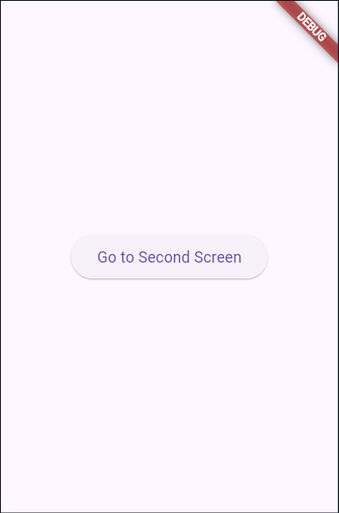 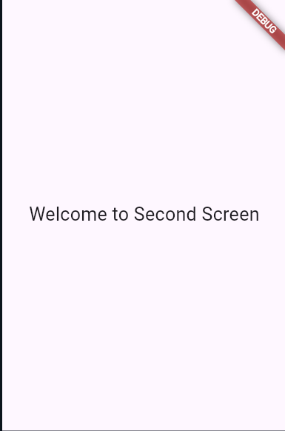

**Date:**

# Practical 7

**AIM: Write android program to demonstrate action button by implementing ONCLICKLISTENER.**

## Program:

**XML Layout (activity_main.xml)**

<?xml version="1.0" encoding="utf-8"?>

<LinearLayout xmlns:android="http://schemas.android.com/apk/res/android"

android:layout_width="match_parent"

android:layout_height="match_parent"

android:orientation="vertical"

android:gravity="center"

android:padding="20dp">

<Button

android:id="@+id/btnClickMe"

android:layout_width="wrap_content"

android:layout_height="wrap_content"

android:text="Click Me" />

<TextView

android:id="@+id/tvResult"

android:layout_width="wrap_content"

android:layout_height="wrap_content"

android:text="Result will appear here"

android:textSize="20sp"

android:layout_marginTop="20dp"/>

</LinearLayout>

**Java Code (MainActivity.java)**

package com.example.onclickdemo;

import androidx.appcompat.app.AppCompatActivity;

import android.os.Bundle;

import android.view.View;

import android.widget.Button;

import android.widget.TextView;

public class MainActivity extends AppCompatActivity implements View.OnClickListener {

Button btnClickMe;

TextView tvResult;

@Override

protected void onCreate(Bundle savedInstanceState) {

super.onCreate(savedInstanceState);

setContentView(R.layout.activity_main);

btnClickMe = findViewById(R.id.btnClickMe);

tvResult = findViewById(R.id.tvResult);

// Set OnClickListener

btnClickMe.setOnClickListener(this);

}

@Override

public void onClick(View v) {

if (v.getId() == R.id.btnClickMe) {

tvResult.setText("Button Clicked Successfully!");

}

## Output :

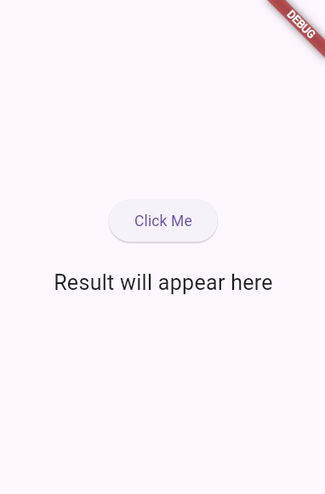 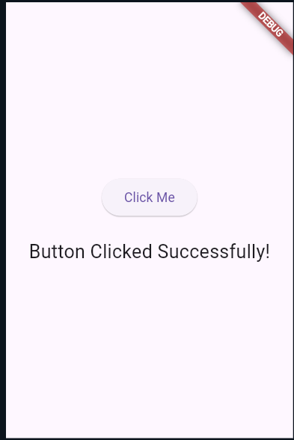

**Date:**

# Practical 8

**AIM: Write android program to demonstrate sound button application.**

## Program:

## XML Layout (activity_main.xml)

## <?xml version="1.0" encoding="utf-8"?>

## <LinearLayout xmlns:android="http://schemas.android.com/apk/res/android"

## android:layout_width="match_parent"

## android:layout_height="match_parent"

## android:orientation="vertical"

## android:gravity="center"

## android:padding="20dp">

## <Button

## android:id="@+id/btnPlaySound"

## android:layout_width="wrap_content"

## android:layout_height="wrap_content"

## android:text="Play Sound" />

## </LinearLayout>

## Java Code (MainActivity.java)

## package com.example.soundbuttonapp;

## import androidx.appcompat.app.AppCompatActivity;

## import android.media.MediaPlayer;

## import android.os.Bundle;

## import android.view.View;

## import android.widget.Button;

## public class MainActivity extends AppCompatActivity {

## Button btnPlaySound;

## MediaPlayer mediaPlayer;

## @Override

## protected void onCreate(Bundle savedInstanceState) {

## super.onCreate(savedInstanceState);

## setContentView(R.layout.activity_main);

## btnPlaySound = findViewById(R.id.btnPlaySound);

## // Initialize MediaPlayer with sound file from res/raw

## mediaPlayer = MediaPlayer.create(this, R.raw.clicksound);

## btnPlaySound.setOnClickListener(new View.OnClickListener() {

## @Override

## public void onClick(View v) {

## // Play sound when button clicked

## if (mediaPlayer != null) {

## mediaPlayer.start();

## }

## }

## });

## }

## @Override

## protected void onDestroy() {

## super.onDestroy();

## if (mediaPlayer != null) {

## mediaPlayer.release();

## mediaPlayer = null;

## }

## }

## }

## Output :

## 

**Date:**

# Practical 9

**AIM: Write an Android application to convert into different currencies for example, Rupees to dollar.**

**Program:**

**XML Layout (activity_main.xml)**

<?xml version="1.0" encoding="utf-8"?>

<LinearLayout xmlns:android="http://schemas.android.com/apk/res/android"

android:layout_width="match_parent"

android:layout_height="match_parent"

android:orientation="vertical"

android:gravity="center"

android:padding="20dp">

<EditText

android:id="@+id/etRupees"

android:layout_width="match_parent"

android:layout_height="wrap_content"

android:hint="Enter amount in Rupees"

android:inputType="numberDecimal"

android:layout_marginBottom="15dp"/>

<Button

android:id="@+id/btnConvert"

android:layout_width="wrap_content"

android:layout_height="wrap_content"

android:text="Convert to Dollar" />

<TextView

android:id="@+id/tvResult"

android:layout_width="wrap_content"

android:layout_height="wrap_content"

android:text="Result will appear here"

android:textSize="20sp"

android:layout_marginTop="20dp"/>

</LinearLayout>

**Java Code (MainActivity.java)**

package com.example.currencyconverter;

import androidx.appcompat.app.AppCompatActivity;

import android.os.Bundle;

import android.view.View;

import android.widget.Button;

import android.widget.EditText;

import android.widget.TextView;

import android.widget.Toast;

public class MainActivity extends AppCompatActivity {

EditText etRupees;

Button btnConvert;

TextView tvResult;

// Conversion rate (Example: 1 Rupee = 0.012 USD)

final double DOLLAR_RATE = 0.012;

@Override

protected void onCreate(Bundle savedInstanceState) {

super.onCreate(savedInstanceState);

setContentView(R.layout.activity_main);

etRupees = findViewById(R.id.etRupees);

btnConvert = findViewById(R.id.btnConvert);

tvResult = findViewById(R.id.tvResult);

btnConvert.setOnClickListener(new View.OnClickListener() {

@Override

public void onClick(View v) {

String rupeesStr = etRupees.getText().toString();

if (rupeesStr.isEmpty()) {

Toast.makeText(MainActivity.this, "Please enter amount in Rupees", Toast.LENGTH_SHORT).show();

return;

}

double rupees = Double.parseDouble(rupeesStr);

double dollars = rupees * DOLLAR_RATE;

tvResult.setText("USD: $" + String.format("%.2f", dollars));

}

});

}

}

## Output :

## 

**Date:**

# Practical 10

**AIM: Write an android application to count library overdue.**

**Program:**

**XML Layout (activity_main.xml)**

<?xml version="1.0" encoding="utf-8"?>

<LinearLayout xmlns:android="http://schemas.android.com/apk/res/android"

android:layout_width="match_parent"

android:layout_height="match_parent"

android:orientation="vertical"

android:gravity="center"

android:padding="20dp">

<EditText

android:id="@+id/etDays"

android:layout_width="match_parent"

android:layout_height="wrap_content"

android:hint="Enter number of overdue days"

android:inputType="number"

android:layout_marginBottom="15dp"/>

<Button

android:id="@+id/btnCalculate"

android:layout_width="wrap_content"

android:layout_height="wrap_content"

android:text="Calculate Fine" />

<TextView

android:id="@+id/tvResult"

android:layout_width="wrap_content"

android:layout_height="wrap_content"

android:text="Fine will appear here"

android:textSize="20sp"

android:layout_marginTop="20dp"/>

</LinearLayout>

**Java Code (MainActivity.java)**

package com.example.libraryfine;

import androidx.appcompat.app.AppCompatActivity;

import android.os.Bundle;

import android.view.View;

import android.widget.Button;

import android.widget.EditText;

import android.widget.TextView;

import android.widget.Toast;

public class MainActivity extends AppCompatActivity {

EditText etDays;

Button btnCalculate;

TextView tvResult;

// Fine rate per day

final int FINE_RATE = 2;

@Override

protected void onCreate(Bundle savedInstanceState) {

super.onCreate(savedInstanceState);

setContentView(R.layout.activity_main);

etDays = findViewById(R.id.etDays);

btnCalculate = findViewById(R.id.btnCalculate);

tvResult = findViewById(R.id.tvResult);

btnCalculate.setOnClickListener(new View.OnClickListener() {

@Override

public void onClick(View v) {

String daysStr = etDays.getText().toString();

if (daysStr.isEmpty()) {

Toast.makeText(MainActivity.this, "Please enter overdue days", Toast.LENGTH_SHORT).show();

return;

}

int days = Integer.parseInt(daysStr);

int fine = days * FINE_RATE;

tvResult.setText("Total Fine: ₹" + fine);

}

});

}

}

## Output :

## 

**Date:**

# Practical 11

**AIM: Write an application to mark the daily route of travel in map.**

**Program:**

**XML Layout (activity_main.xml)**

<?xml version="1.0" encoding="utf-8"?>

<fragment xmlns:android="http://schemas.android.com/apk/res/android"

android:id="@+id/map"

android:name="com.google.android.gms.maps.SupportMapFragment"

android:layout_width="match_parent"

android:layout_height="match_parent"/>

**Java Code (MainActivity.java)**

package com.example.dailyroute;

import androidx.fragment.app.FragmentActivity;

import android.os.Bundle;

import com.google.android.gms.maps.CameraUpdateFactory;

import com.google.android.gms.maps.GoogleMap;

import com.google.android.gms.maps.OnMapReadyCallback;

import com.google.android.gms.maps.SupportMapFragment;

import com.google.android.gms.maps.model.LatLng;

import com.google.android.gms.maps.model.MarkerOptions;

import com.google.android.gms.maps.model.PolylineOptions;

public class MainActivity extends FragmentActivity implements OnMapReadyCallback {

private GoogleMap mMap;

@Override

protected void onCreate(Bundle savedInstanceState) {

super.onCreate(savedInstanceState);

setContentView(R.layout.activity_main);

SupportMapFragment mapFragment = (SupportMapFragment) getSupportFragmentManager()

.findFragmentById(R.id.map);

if (mapFragment != null) {

mapFragment.getMapAsync(this);

}

}

@Override

public void onMapReady(GoogleMap googleMap) {

mMap = googleMap;

// Example route: Home -> Bus Stop -> Office

LatLng home = new LatLng(28.6139, 77.2090); // Delhi example

LatLng busStop = new LatLng(28.6200, 77.2100);

LatLng office = new LatLng(28.6250, 77.2150);

// Add markers

mMap.addMarker(new MarkerOptions().position(home).title("Home"));

mMap.addMarker(new MarkerOptions().position(busStop).title("Bus Stop"));

mMap.addMarker(new MarkerOptions().position(office).title("Office"));

// Draw route with Polyline

mMap.addPolyline(new PolylineOptions()

.add(home, busStop, office)

.width(8)

.color(0xFF2196F3)); // Blue

// Move camera to Home

mMap.moveCamera(CameraUpdateFactory.newLatLngZoom(home, 14));

}

}

## Output :

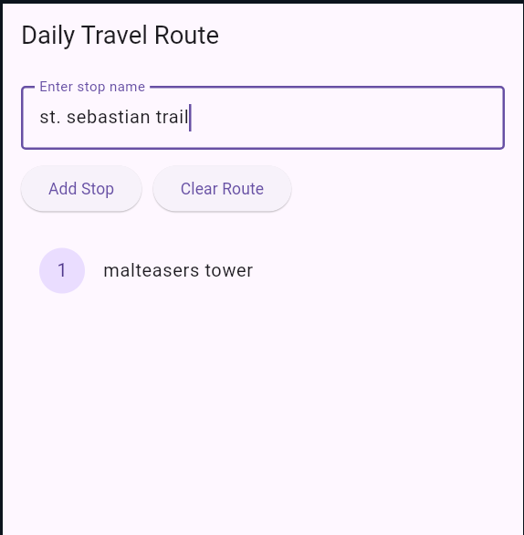 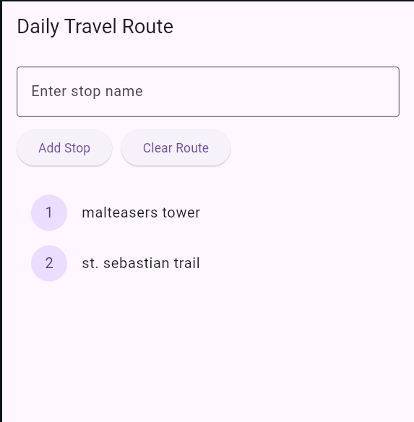

**Date:**

# Practical 13

**AIM: Write an application to record video and audio on topic "Intent" and play the audio and video.**

## Program:

## AndroidManifest.xml

## <uses-permission android:name="android.permission.CAMERA"/>

## <uses-permission android:name="android.permission.RECORD_AUDIO"/>

## <uses-permission android:name="android.permission.WRITE_EXTERNAL_STORAGE"/>

## <uses-permission android:name="android.permission.READ_EXTERNAL_STORAGE"/>

## <application

## ...>

## <activity android:name=".MainActivity">

## <intent-filter>

## <action android:name="android.intent.action.MAIN"/>

## <category android:name="android.intent.category.LAUNCHER"/>

## </intent-filter>

## </activity>

## </application>

## XML Layout (activity_main.xml)

## <?xml version="1.0" encoding="utf-8"?>

## <LinearLayout xmlns:android="http://schemas.android.com/apk/res/android"

## android:orientation="vertical"

## android:gravity="center"

## android:layout_width="match_parent"

## android:layout_height="match_parent"

## android:padding="20dp">

## <Button

## android:id="@+id/btnRecordAudio"

## android:layout_width="wrap_content"

## android:layout_height="wrap_content"

## android:text="Record Audio"/>

## <Button

## android:id="@+id/btnRecordVideo"

## android:layout_width="wrap_content"

## android:layout_height="wrap_content"

## android:text="Record Video"

## android:layout_marginTop="15dp"/>

## <Button

## android:id="@+id/btnPlayAudio"

## android:layout_width="wrap_content"

## android:layout_height="wrap_content"

## android:text="Play Audio"

## android:layout_marginTop="15dp"/>

## <Button

## android:id="@+id/btnPlayVideo"

## android:layout_width="wrap_content"

## android:layout_height="wrap_content"

## android:text="Play Video"

## android:layout_marginTop="15dp"/>

## </LinearLayout>

## Java Code (MainActivity.java)

## package com.example.intentmediaapp;

## import androidx.appcompat.app.AppCompatActivity;

## import android.content.Intent;

## import android.net.Uri;

## import android.os.Bundle;

## import android.provider.MediaStore;

## import android.view.View;

## import android.widget.Button;

## import android.widget.Toast;

## public class MainActivity extends AppCompatActivity {

## Button btnRecordAudio, btnRecordVideo, btnPlayAudio, btnPlayVideo;

## Uri audioUri, videoUri;

## final int AUDIO_REQUEST = 1;

## final int VIDEO_REQUEST = 2;

## @Override

## protected void onCreate(Bundle savedInstanceState) {

## super.onCreate(savedInstanceState);

## setContentView(R.layout.activity_main);

## btnRecordAudio = findViewById(R.id.btnRecordAudio);

## btnRecordVideo = findViewById(R.id.btnRecordVideo);

## btnPlayAudio = findViewById(R.id.btnPlayAudio);

## btnPlayVideo = findViewById(R.id.btnPlayVideo);

## // Record Audio

## btnRecordAudio.setOnClickListener(new View.OnClickListener() {

## @Override

## public void onClick(View v) {

## Intent audioIntent = new Intent(MediaStore.Audio.Media.RECORD_SOUND_ACTION);

## try {

## startActivityForResult(audioIntent, AUDIO_REQUEST);

## } catch (Exception e) {

## Toast.makeText(MainActivity.this, "No app found to record audio", Toast.LENGTH_SHORT).show();

## }

## }

## });

## // Record Video

## btnRecordVideo.setOnClickListener(new View.OnClickListener() {

## @Override

## public void onClick(View v) {

## Intent videoIntent = new Intent(MediaStore.ACTION_VIDEO_CAPTURE);

## try {

## startActivityForResult(videoIntent, VIDEO_REQUEST);

## } catch (Exception e) {

## Toast.makeText(MainActivity.this, "No app found to record video", Toast.LENGTH_SHORT).show();

## }

## }

## });

## // Play Audio

## btnPlayAudio.setOnClickListener(new View.OnClickListener() {

## @Override

## public void onClick(View v) {

## if (audioUri != null) {

## Intent playAudio = new Intent(Intent.ACTION_VIEW);

## playAudio.setDataAndType(audioUri, "audio/*");

## startActivity(playAudio);

## } else {

## Toast.makeText(MainActivity.this, "No audio recorded", Toast.LENGTH_SHORT).show();

## }

## }

## });

## // Play Video

## btnPlayVideo.setOnClickListener(new View.OnClickListener() {

## @Override

## public void onClick(View v) {

## if (videoUri != null) {

## Intent playVideo = new Intent(Intent.ACTION_VIEW);

## playVideo.setDataAndType(videoUri, "video/*");

## startActivity(playVideo);

## } else {

## Toast.makeText(MainActivity.this, "No video recorded", Toast.LENGTH_SHORT).show();

## }

## }

## });

## }

## @Override

## protected void onActivityResult(int requestCode, int resultCode, Intent data) {

## super.onActivityResult(requestCode, resultCode, data);

## if (resultCode == RESULT_OK) {

## if (requestCode == AUDIO_REQUEST) {

## audioUri = data.getData();

## } else if (requestCode == VIDEO_REQUEST) {

## videoUri = data.getData();

## }

## }

## }

## }

## Output :

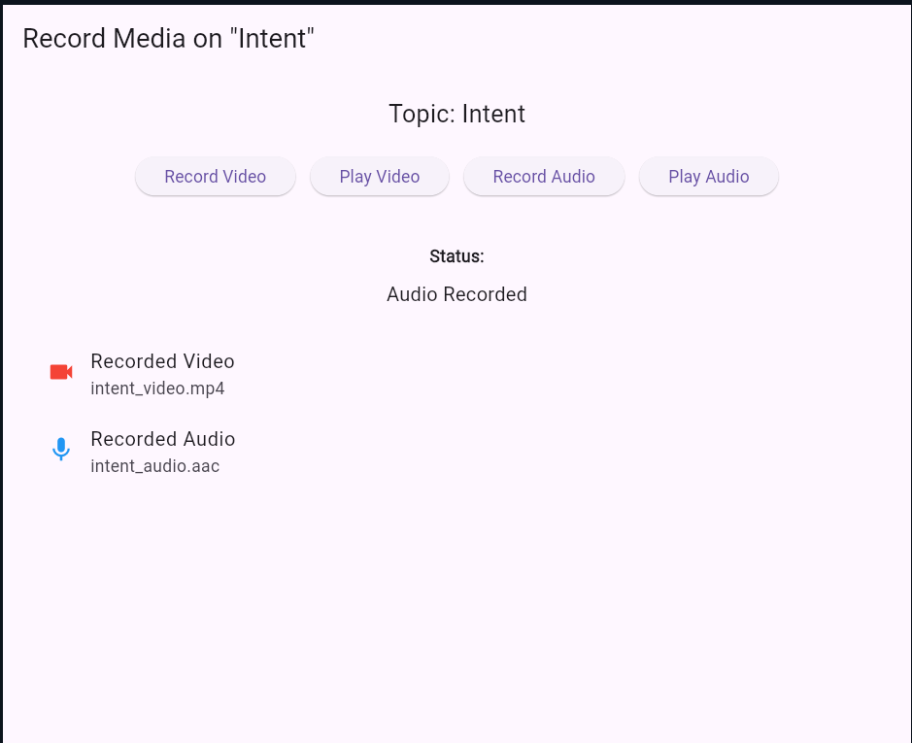

**Date:**

# Practical 14

**AIM: Write android program to set the wallpaper of your device using bitmap class.**

## Program:

## XML Layout (activity_main.xml)

## <?xml version="1.0" encoding="utf-8"?>

## <LinearLayout xmlns:android="http://schemas.android.com/apk/res/android"

## android:orientation="vertical"

## android:gravity="center"

## android:layout_width="match_parent"

## android:layout_height="match_parent"

## android:padding="20dp">

## <Button

## android:id="@+id/btnSetWallpaper"

## android:layout_width="wrap_content"

## android:layout_height="wrap_content"

## android:text="Set Wallpaper"/>

## </LinearLayout>

## Java Code (MainActivity.java)

## package com.example.wallpaperapp;

## import androidx.appcompat.app.AppCompatActivity;

## import android.app.WallpaperManager;

## import android.graphics.Bitmap;

## import android.graphics.BitmapFactory;

## import android.os.Bundle;

## import android.view.View;

## import android.widget.Button;

## import android.widget.Toast;

## import java.io.IOException;

## public class MainActivity extends AppCompatActivity {

## Button btnSetWallpaper;

## @Override

## protected void onCreate(Bundle savedInstanceState) {

## super.onCreate(savedInstanceState);

## setContentView(R.layout.activity_main);

## btnSetWallpaper = findViewById(R.id.btnSetWallpaper);

## btnSetWallpaper.setOnClickListener(new View.OnClickListener() {

## @Override

## public void onClick(View v) {

## // Load bitmap from drawable

## Bitmap bitmap = BitmapFactory.decodeResource(getResources(), R.drawable.wallpaper_image);

## // Set wallpaper using WallpaperManager

## WallpaperManager wallpaperManager = WallpaperManager.getInstance(getApplicationContext());

## try {

## wallpaperManager.setBitmap(bitmap);

## Toast.makeText(MainActivity.this, "Wallpaper Set Successfully", Toast.LENGTH_SHORT).show();

## } catch (IOException e) {

## e.printStackTrace();

## Toast.makeText(MainActivity.this, "Failed to Set Wallpaper", Toast.LENGTH_SHORT).show();

## }

## }

## });

## }

## }

## Output :

## 